ALLERGENS: CHEF RECIPE CARDS
ALLERGENS: CHEF RECIPE CARDS

Dish/ingredient:

Date: |  | Chef:

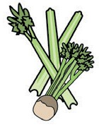  Celery | 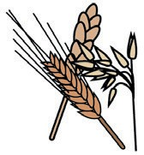  Cereals containing gluten | 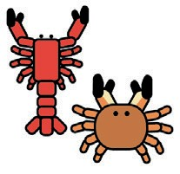  Crustaceans | 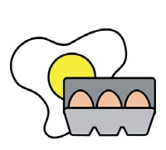  Eggs |   Fish
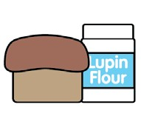  Lupin |   Milk |   Mollusc | 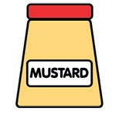  Mustard | 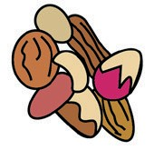  Nuts
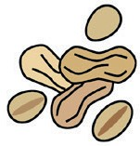  Peanuts | 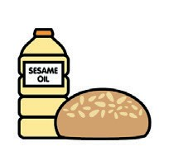  Sesame seeds |   Soya | 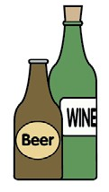  Sulphur Dioxide | TICK THE ALLERGENS WHICH ARE IN THE DISH
 |  |  |  | ☑

Notes:
Reviewed and checked by:

Dish/ingredient:

Date: |  | Chef:

Celery | Cereals containing gluten | Crustaceans | Eggs | Fish
Lupin | Milk | Mollusc | Mustard | Nuts
Peanuts | Sesame seeds | Soya | Sulphur Dioxide | TICK THE ALLERGENS WHICH ARE IN THE DISH
 |  |  |  | ☑

Notes:
Reviewed and checked by:

 | You can find this template and others, including  more information at www.food.gov.uk/allergy |  |  | You can find this template and others, including  more information at www.food.gov.uk/allergy

